Task1

* 1. Select a business process, as this will define what you are going to measure with the data you store. The business process will determine the grain, facts, and dimensions.

The business process represented in the ERD involves sales transactions.

* 1. Determine the grain, or the level of detail, to see what a row in the fact table will represent, e.g., product delivery information by location by day.

The grain is each individual sales transaction.

* 1. Identify the dimensions (product, delivery, location, time, etc.) as they describe where all data should be stored.

all the dimensions are: products, customers, locations( I mean address), employees and stores

* 1. Identify facts, or the numerical results of the business process, which is an observable event (e.g., delivery by product/location/time).

facts are quantity orders, sales amount and price each as well as order line number.

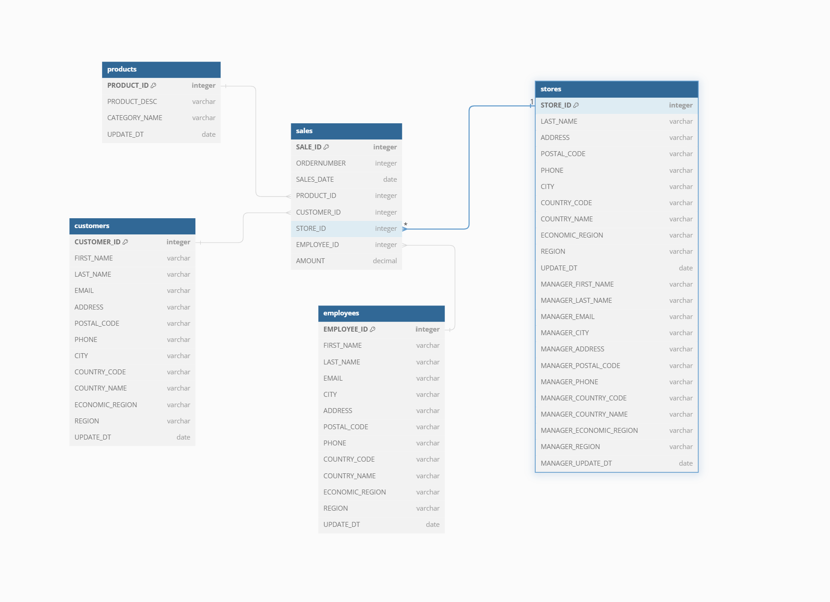

The star schema. For the star schema because I divided main dimensions, I needed to deformalize the data such that only sales table kept foreign keys. And everywhere else (for example addresses) deformalized tables. Like in the stores, take all the employee information( which already had added address information containing: region, country, city and address) and make It for the manager, as leaving manager id would not be okay for the star schema as it contains reference to employee and for the star schema I only needed one foreign key to the facts table(sales)

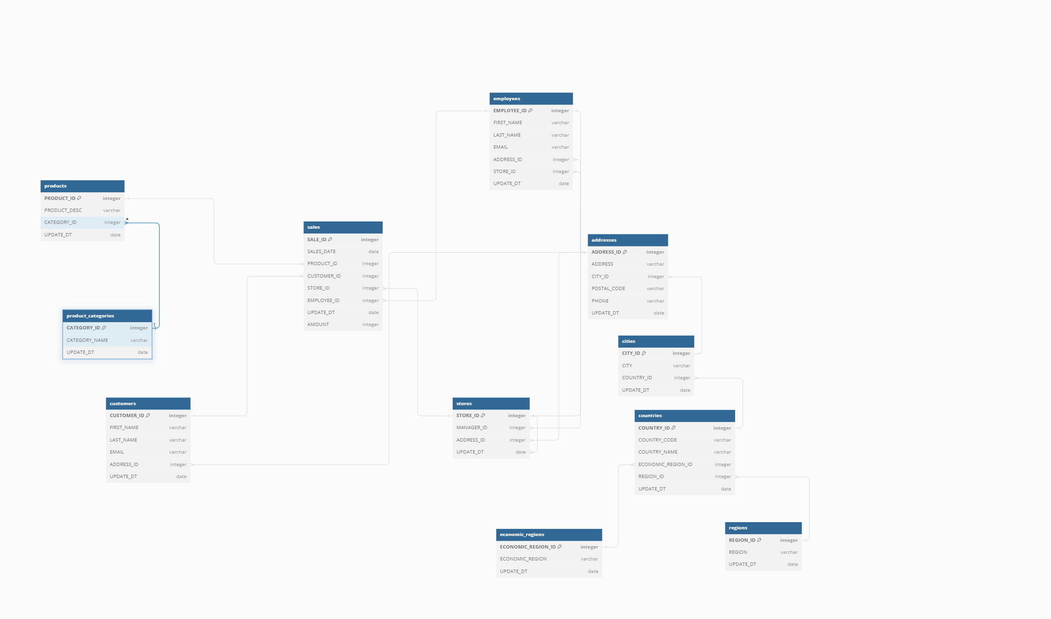

I did not change anything here, except that I added amount from payment into sales table, assuming that one payment means one sales record. That way sales is the fact table and finally we have snowflake schema.